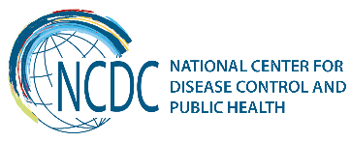

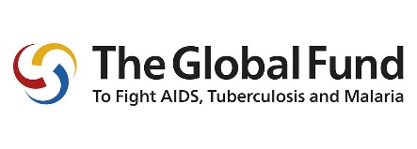
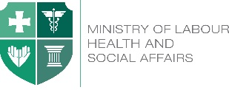

GEORGIA Brief
Global Fund to Fight AIDS, TB and Malaria Programs in Georgia
Georgia is implementing programs supported by the Global Fund since 2003 when the first request for funding was approved for HIV Program. Since then, the country has received over 119,2 million USD investment to support the implementation of HIV, TB and Malaria programs (74.1 million for HIV Program, 41,9 million for TB and 3,5 million for malaria Program).
The Global Fund support was instrumental for:
- Elimination of malaria and no local case of malaria has been detected since 2010;
- Development and implementation of effective HIV response, which allowed to maintain low HIV prevalence status of the country and to provide universal access to lifesaving antiretroviral treatment for people living with HIV, diagnostics, and treatment; currently 4310 patients are on ART;
- Prevention of mother to child transmission of HIV through universal access to screening and prophylaxis treatment;
- Establishing effective TB response strategy and provision of universal anti-TB treatment for both, sensitive and MDR TB patients, setting up a network of laboratories and ensuring the functioning of quality control interventions; more than 20,000 patients received anti-TB treatment with the support of the Global Fund.

Components | Signed | Committed | Disbursed
HIV | US$84,351,026 | US$78,187,522 | US$74,066,047
TB | US$50,585,396 | US$46,354,378 | US$41,889,518
Malaria | US$3,500,710 | US$3,500,710 | US$3,500,710
TOTAL | US$138,437,132 | US$128,042,610 | US$119,456,275

Programmatic Achievements
Since 2005 all people living with HIV enjoy universal access to ART in Georgia, including individuals living in conflict zone -- Abkhazia. The Georgian ART Program is recognised as one of the best in the region due to its high coverage, good retention rates and high quality of the services provided. As early as in 2015, Georgia initiated WHO Treat All strategy and individuals were offered ART despite their CD4 count.

With the Global Fund support, Georgia was able to achieve significant break-through to provide HIV prevention services to communities most affected by HIV:
- Georgia was one of the first in the region to start Opiate Substitution Treatment program (in 2005), including in prisons;
- Needle and Syringe Programs scaled-up and operate from 14 drop-in centres and 8 mobile ambulatories, covering up to 55 cities;
- HIV counselling and testing services and commodities are available to female sex workers (FSW) and men who have sex with men (MSM) in 5 most affected cities of the country through intensive outreach work and community resource centres.
- Georgia is the first in the region to start a pilot on PrEP among MSM community (September 2017) with a plan to expand the program in the future.
The main challenges of HIV Program are low HIV case detection and high late diagnosis rates, which needs acceleration of HIV testing and councelling services among KAPs that is largely supported by the Global Fund HIV Program.
The Georgian national TB program has achieved remarkable successes in the uptake and implementation of contemporary international strategies and guidance in TB control.
- Visible reduction of TB Burden has been documented in recent years, reflected in decreasing number of TB cases.
- The universal access is ensured to diagnosis and treatment of all forms of TB, including M/XDR-TB.
- The use of novel rapid diagnostic methods, as well as of newly developed drugs is scaled-up; in parallel, active drug safety monitoring system was introduced.
- Modern technologies are utilized to improve access to out-patient treatment through Video Observed Therapy pilot program.
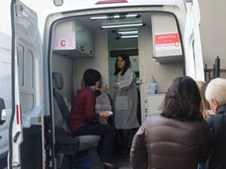
Georgia is one of the countries supported by the Global Fund Tuberculosis Regional Eastern Europe and Central Asia Project (TB-REP) and country strives to achieve “a people-centered model of TB care” as articulated in blueprint framework developed by the TB-REP project.
Within the Global Fund TB program, Georgia started implementation of Zero TB Initiative in Adjara region as a coalition of the local government, businesses, and civil society. The aim is to create an “island of elimination” that will contribute to lowering rates of TB through the country.
The hepatitis C elimination program has created a unique momentum for scale up of detection of HIV, HCV and TB cases in Georgia. This year with the Global Fund support Georgia has started a pilot project in one of the highest prevalence regions of Georgia (Samegrelo) to test the potential integration of HIV, TB and HCV screening services at the regional level with the increasing role of primary care in the detection and management of all three diseases under the “one umbrella”. The regional steering committee advocates and leads the implementation of the program with the support of the MoLHSA, NCDC and National TB and AIDS Centers. Based on the results coming from the pilot project, later the program might be expanded to other regions of the country.
Sustainability of Programs in Georgia
Since 2016 Georgia is implementing the New Funding Model grants (18,4 million USD for HIV and 12,1 million for TB) for which the Government has fully met the co-funding requirements. For both the HIV and TB programs the Government’s share of funding for the last three years has exceeded 60% of the total funding for the Programs.
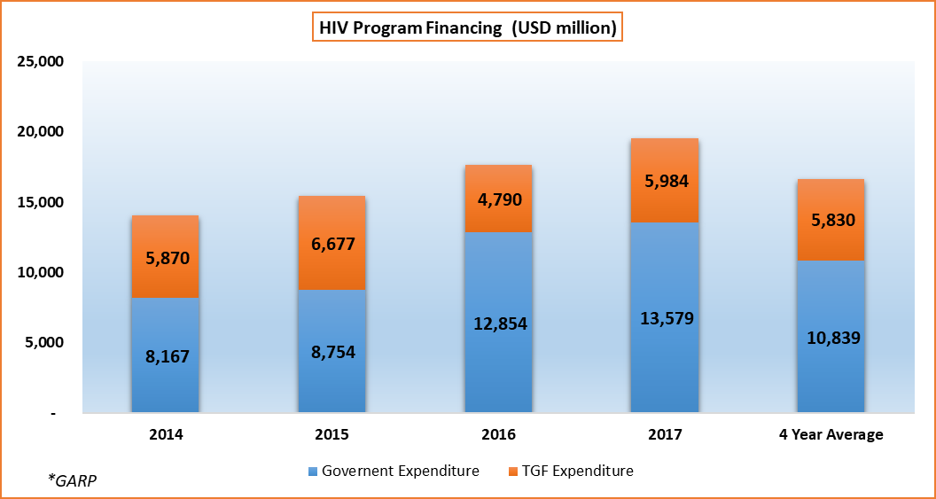 | 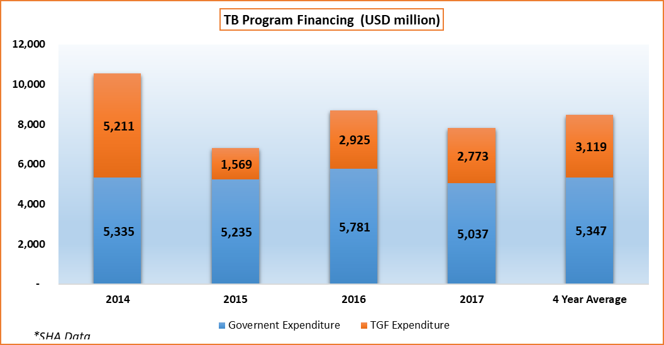
Anticipated support from the Global Fund will be halved for the next 3-year funding cycle and the country is eligible for only 15.8 million additional funding. The Government of Georgia is on track to the mobilization of domestic resources to ensure sustainability and scale-up of programs in response to the epidemics.
In response to transition challenges, Georgia has developed a Sustainability and Transition Plan for the period of 2017-2019 with a broad stakeholder engagement and CCM leading. The Plan addresses immediate and long-term challenges for ensuring a smooth transition of the Global Fund supported programs.
The Government has already stepped in to provide funding for the services, while community and civil society actors ensure close monitoring and stay engaged in the planning and implementation processes.
_________________________________________________________________________________
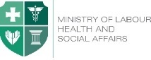  Ministry of Labour, Health and Social Affairs of Georgia  144, A. Tsereteli avenue. Tbilisi, Georgia, 0119  www.moh.gov.ge | 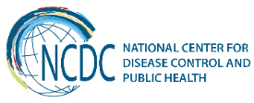  National Center for Disease Control and Public Health  9, M. Asatiani street. Tbilisi, Georgia, 0177  www.ncdc.ge

